How to hold a
PERCY PARTY!

An EVENT KIT for the PERCY JACKSON AND THE OLYMPIANS series

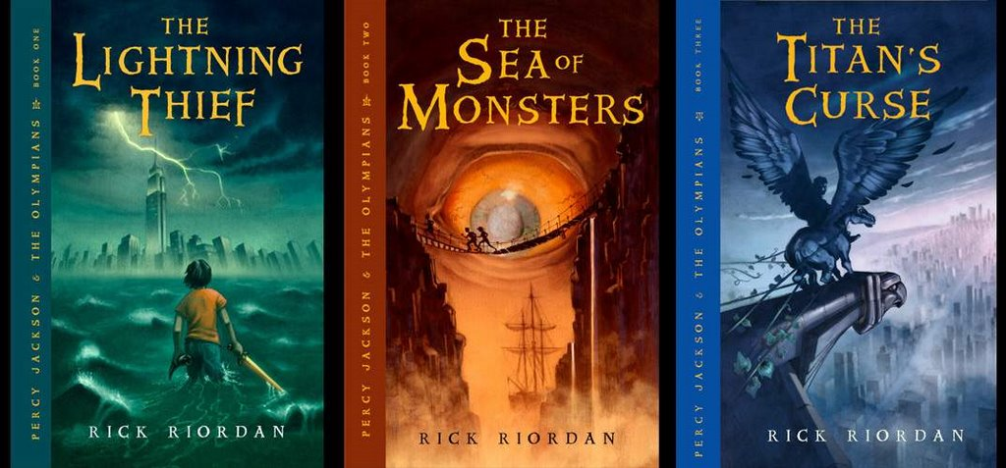
The Lightning Thief The Sea of Monsters The Titan’s Curse
Paperback Paperback Hardcover
0786838655 1423103343 1423101456
$7.99 $7.99 $16.95

"Perfectly paced, with electrifying moments chasing each other like heartbeats." – New York Times Book Review
“A Fantastic Blend of myth and modern.”
– Eoin Colfer
A BookSense children’s series bestseller
A Publishers Weekly children’s bestseller

Hyperion Books for Children Hyperionbooksforchildren.com
114 Fifth Avenue, New York, NY 10011 Rickriordan.com

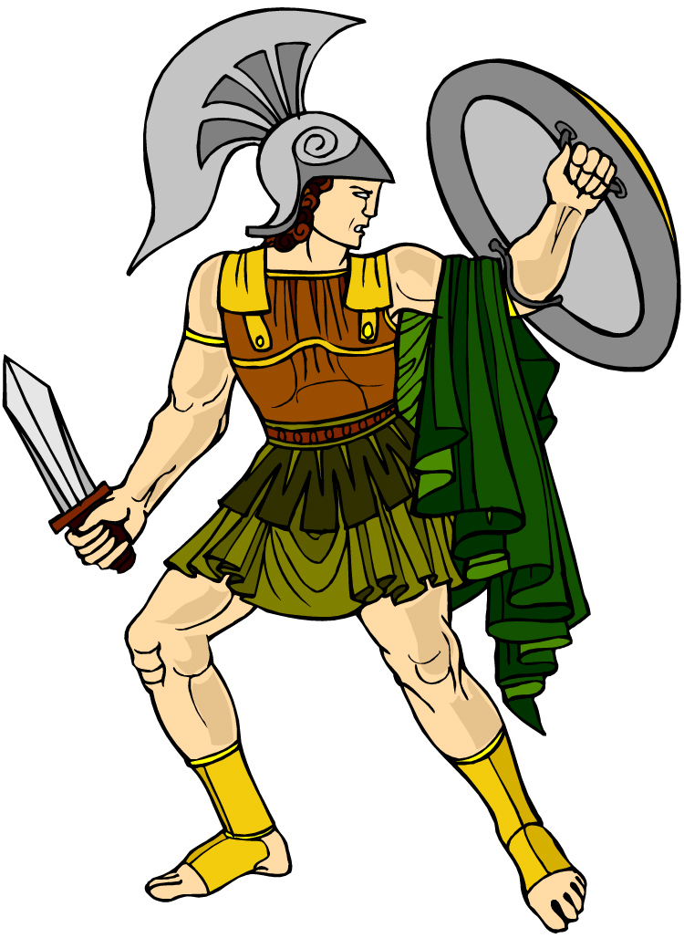

Dear Bookseller:

Get your bronze sword and shield ready. Percy Jackson is in trouble again. His friend Annabeth has been abducted by a manticore. The goddess Artemis is missing. And a new prophecy has warned of a monster so powerful it could destroy Mount Olympus unless it is found quickly. The Titan’s Curse, the third adventure in the bestselling Percy Jackson and the Olympians series, arrives May 1, 2007!

Because many bookstores have expressed interest in holding a “Percy Party” to celebrate the publication of the new book, I’m pleased to offer this event kit. In it, you will find everything you need for a great in-store party: Greek mythology activities, an event flier, games and prizes, Ancient Greek name tags, and more.

Thank you for all the support you’ve given the series. The hand-selling and word-of-mouth recommendations have been incredible! I hope you enjoy the new book, and have a great event with all the young demigods in your area!

Best wishes from Camp Half-Blood,

Rick Riordan

The Percy Party at a Glance:

1. Making Name Tags

As guests arrive, encourage them to make name tags with their names in English and Ancient Greek.

A reproducible handout with the Greek alphabet is provided to help guests learn to write their names.

2. Self-Paced Activities

The following reproducible handouts are included:

Greek gods coloring sheets
Draw Your Own Fury (Have paper and crayons or markers available)
Make Your Own Greek Vase

These can be used as in-store “warm-up” activities while your guests are arriving, or given out as fun take-home projects. Customer-created artwork also makes for a great in-store display after the event.

3. Word Search Raffle

The Percy Jackson word search can be filled out before or during the event. Collect these and use them as drawing slips for prizes. A Greek mythology book makes a great giveaway.

4. A Reading from the Titan’s Curse

Have a ‘reader’s theater’ based on a section of The Titan’s Curse (ch. 2 is recommended). Ask for volunteers to play the dialogue parts. A bookseller can act as narrator. Alternately, a bookseller may choose to read a passage from The Titan’s Curse.

5. The Claiming Ceremony

Allow your demigod guests to consult the Oracle to find out which Greek god will claim them! Print a large version of the Oracle’s wheel, then laminate and attach a spinner. (A ruler works well for this.) The wheel can be used as an in-store display before and after the event, too! You will have the only working Oracle in town.

6. Mythology Quiz Game

Hold a friendly competition to see how much your guests know about Greek mythology and the Percy Jackson books. Thirty sample questions with answers are attached. A reference chart on the Greek gods is also included. This can be used to generate extra questions, or as a refresher sheet for the contestants. For correct answers, you may wish to award small prizes. Blue candy (Percy Jackson’s favorite kind) is always a popular option!

6. Refreshment Ideas

“Nectar” punch or soda
“Ambrosia” brownies or cookies – Don’t eat too many, or you might go up in flames!
Lightning-bolt-shaped cookies
Fresh strawberries (from Camp Half-Blood)

7. Other Greek mythology books

You may want to have these on display along with the Percy Jackson series:

Evslin, Bernard. Heroes, Gods, and Monsters of the Greek Myths. ISBN: 0553259202

D’Aulaire, Ingri. D’Aulaires’ Book of Greek Myths. ISBN: 0440406943

Osborne, Mary Pope. Tales from the Odyssey. ISBN: 0786809280

Evans, Cheryl. Usborne Illustrated Guide to Greek Myths and Legends. ISBN: ISBN: 0860209466

CAMP HALF-BLOOD WANTS YOU!

► Do you think your teachers are secretly monsters?

► Do you suspect you have hidden powers?

► Could your real father or mother be an Olympian god?

YOU ARE NOT ALONE!
JOIN US FOR A CAMP HALF-BLOOD REGIONAL MEETING, CELEBRATING THE ARRIVAL OF THE THIRD PERCY JACKSON ADVENTURE, THE TITAN’S CURSE. ALL YOUNG DEMIGODS ARE INVITED.

Games! Prizes! Find out which Greek god is your parent!

DATE:

TIME:

PLACE:

Learning Ancient Greek

Percy takes lessons in Ancient Greek from Annabeth every morning. He says a demigod’s brain is “hardwired” for Greek. Try your hand at learning the Greek alphabet below. Try writing your name and the names of the Olympian gods using Greek letters.

Lower case Upper case Name of letter English letter Pronunciation
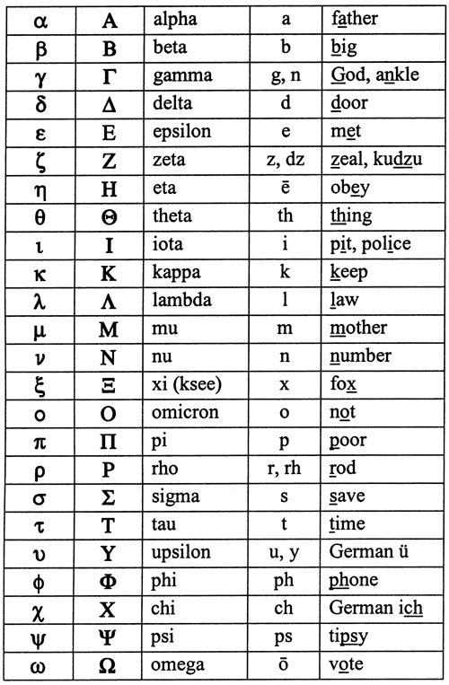
The Percy Jackson Word Search

  PERCY
  ANNABETH
  GROVER
  CLARISSE
  CHIRON
  ARES
  SALLY
  GABE
  RIPTIDE
  LUKE
  HEPHAESTUS
  LONGISLAND
  DIONYSUS
  HELLHOUND
  HALFBLOOD
  ZEUS
  POSEIDON
  ATHENA
  N | A | G | M | W | S | I | B | D | G | A | B | E | H | J | U | D | J | O | G
  V | H | G | R | S | M | L | O | N | G | I | S | L | A | N | D | D | I | A | K
  K | K | R | U | U | G | L | K | A | S | W | G | O | J | K | U | R | T | C | G
  R | O | O | X | E | Z | W | R | D | V | H | T | E | B | A | N | N | A | C | J
  F | Q | V | C | Z | Q | E | S | B | H | H | E | U | P | H | X | V | F | M | P
  M | R | E | S | D | E | P | T | D | P | C | U | K | X | W | U | E | V | B | M
  E | Y | R | X | T | A | Z | E | E | I | E | U | N | U | Q | X | J | J | H | H
  J | C | A | D | W | X | A | O | R | M | O | I | D | B | L | N | A | E | F | H
  L | D | A | R | I | Z | K | V | J | C | I | N | W | E | H | L | P | B | S | A
  A | H | R | I | P | T | I | D | E | E | Y | J | Y | H | Q | H | O | A | F | L
  M | G | V | T | S | U | S | X | O | E | N | Z | X | S | A | F | S | U | A | F
  D | N | U | O | H | L | L | E | H | O | J | N | G | E | U | Y | E | C | Q | B
  O | T | F | U | K | Q | T | D | R | P | V | L | S | X | J | S | I | L | M | L
  Q | C | H | M | G | J | H | I | Q | C | Z | T | R | O | W | G | D | A | L | O
  L | O | E | G | X | F | H | H | P | L | U | A | P | U | G | D | O | R | J | O
  S | M | N | S | K | C | J | M | Y | S | D | D | T | R | Q | X | N | I | B | D
  Y | A | N | O | L | E | B | N | C | X | Q | M | O | H | Q | X | A | S | E | W
  G | I | L | L | Q | B | B | O | A | R | E | S | K | H | E | O | T | S | F | E
  H | U | T | L | O | X | H | K | E | T | Z | J | Y | X | U | N | O | E | C | M
  D | Q | W | S | Y | S | I | I | L | U | F | S | Z | Q | J | P | A | M | Z | V

Your Name: _________________________________________________

Complete this word search and turn it in for a chance to win a prize!

The 12 Olympian Gods + 2

God/Goddess Sphere of Control animal/symbol

1. Zeus | Sky, lord of the gods | Eagle, lightning bolt
2. Hera | Motherhood, marriage | Cow (motherly animal), lion, peacock
3. Poseidon | Sea, earthquakes | Horse, trident
4. Demeter | Agriculture | Red poppy, barley
5. Hephaestus | blacksmiths | Anvil, quail (hops funny like him)
6. Athena | Wisdom, battle, useful arts | owl
7. Aphrodite | Love | Dove, magic belt (that makes men fall for her)
8. Ares | War | Wild boar, bloody spear
9. Apollo | Music, medicine, poetry, archery, bachelors | Mouse, lyre
10. Artemis | (Apollo’s twin sister) Maiden girls, hunting | She-bear
11. Hermes | Travelers, merchants, thieves, messengers | Caduceus, winged helm and sandals
12. Dionysus | wine | Tiger, grapes
13. Hestia | Home and hearth | Crane (gave up her council seat for Dionysus)
14. Hades | underworld | Helm of terror

Sample Quiz Game Questions:
- 1. Who is Annabeth's mother? (Athena)
- Who is Clarisse's father? (Ares)
- What sort of creature is Mr. Brunner? (centaur)
- What sort of creature is Grover? (satyr)
- Two words: What is the name of Percy's boarding school? (Yancy Academy)
- The three old women Percy sees on the side of the road are actually the Three ________. (Fates)
- How many Olympian gods are there? (12)
- What type of tree is on top of Half Blood Hill? (pine)
- What is Mr. D's full name? (Dionysus)
- Who were the enemies that fought a major war with the Gods? (Titans)
- What sort of animal head hangs above Ares' cabin? (boar)
- Name one thing that Hermes is the god of. (travelers, thieves, merchants, roads)
- Who is the wife of Zeus? (Hera)
- What is the pattern on Mr. D's shirt? (tiger)
- Where do Percy and his mother like to go on vacation? (Montauk)
- Three words: according to Percy's mom, how did his dad disappear? (lost at sea)
- Who is Dionysus' father? (Zeus)
- What is Dionysus restricted from? (wine, alcohol)
- What part of the Big House seems mysterious to Percy? (attic)
- What does Percy use to defeat Clarisse when she tries to bully him? (toilets, plumbing)
- What lives in the canoe lake? (Naiads)
- Two words: Dionysus was grounded to Camp Half Blood because he was chasing a what? (wood nymph)
- Aside from pinochle, what is another game Dionysus considers the greatest human achievement? (gladiator fighting or Pacman)
- Two words: How did Percy's mother's parents die? (airplane crash)
- What is Smelly Gabe's last name? (Ugliano)
- What sort of creature tried to attack young Percy when he was taking a nap in daycare? (snake)
- Who was Zeus' mother, who hid him from Cronos? (Rhea)
- Chiron says the United States eagle is actually a symbol of who? (Zeus)
- Chiron says there is a statue of what Greek mythological figure in Rockefeller Center? (Prometheus)
- Who is the Greek lord of the dead? (Hades)

Draw Your Own Fury
The Ancient Greeks had many different ideas about what the Three Furies looked like. Below are some depictions from Ancient Greek pottery. Draw your own updated version of what modern Furies might look like.
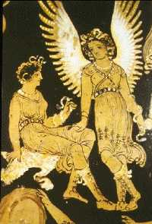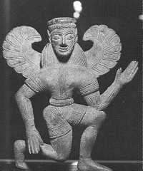

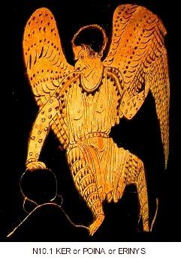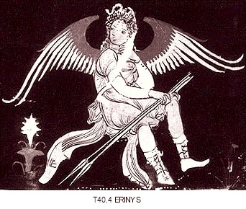
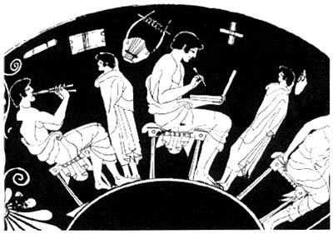
Make your own Greek Vase
Greek vases often showed pictures of daily life or scenes from myths. The vases were usually had a fancy border design around the edges. Below are some examples.

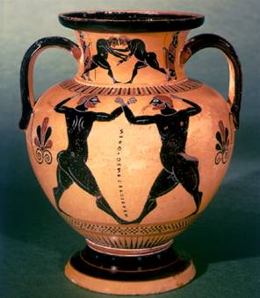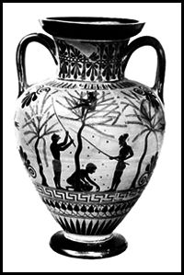

Design your own Greek vase showing a scene from the Percy Jackson books. This could be an important event or simply a scene from every day life at camp. Use the blank shape below to draw the shape of a vase and plan your design. If you would prefer, you can use a circular plate. The design at the top of the page is part of a Greek dinner plate.

Make your own Greek vase

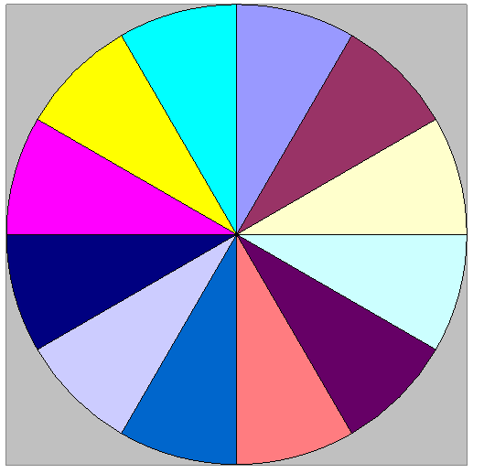
ZEUS
POSEIDON
HADES
APOLLO
HERMES
ATHENA
DIONYSUS
HEPHAESTUS
DEMETER
APHRODITE
ARES
HUNTER OF ARTEMIS

THE ORACLE’S WHEEL

Let the Oracle of Delphi determine which Olympian claims you!

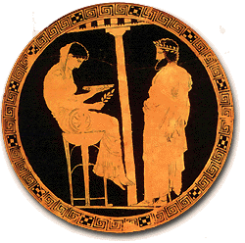

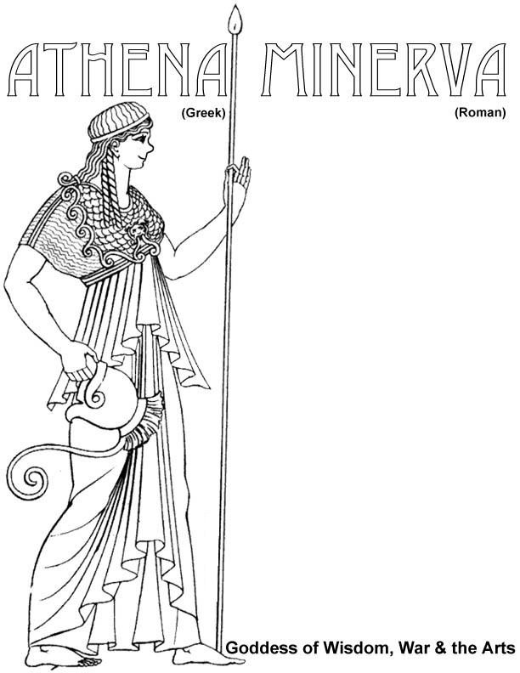
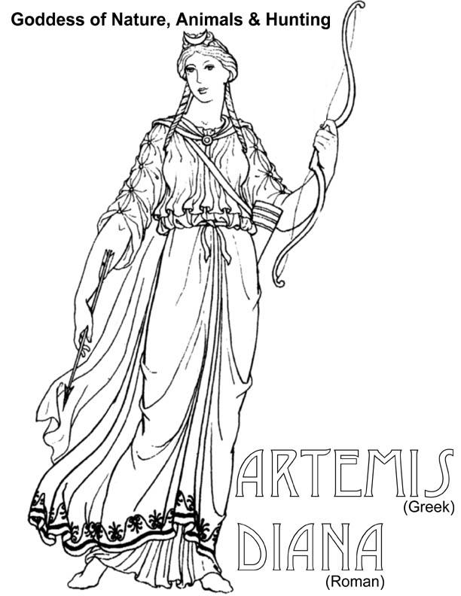
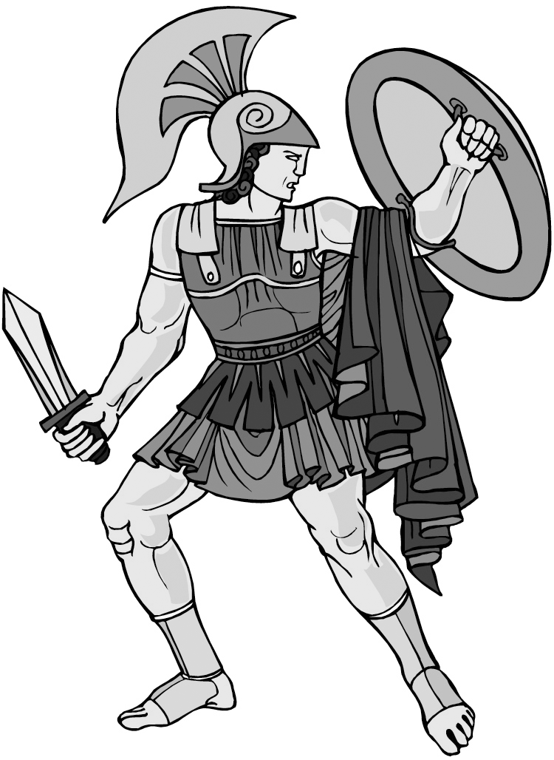
ARES (Greek) MARS (Roman) God of War

